CS 255 System Design Document

UML Diagrams

UML Use Case Diagram
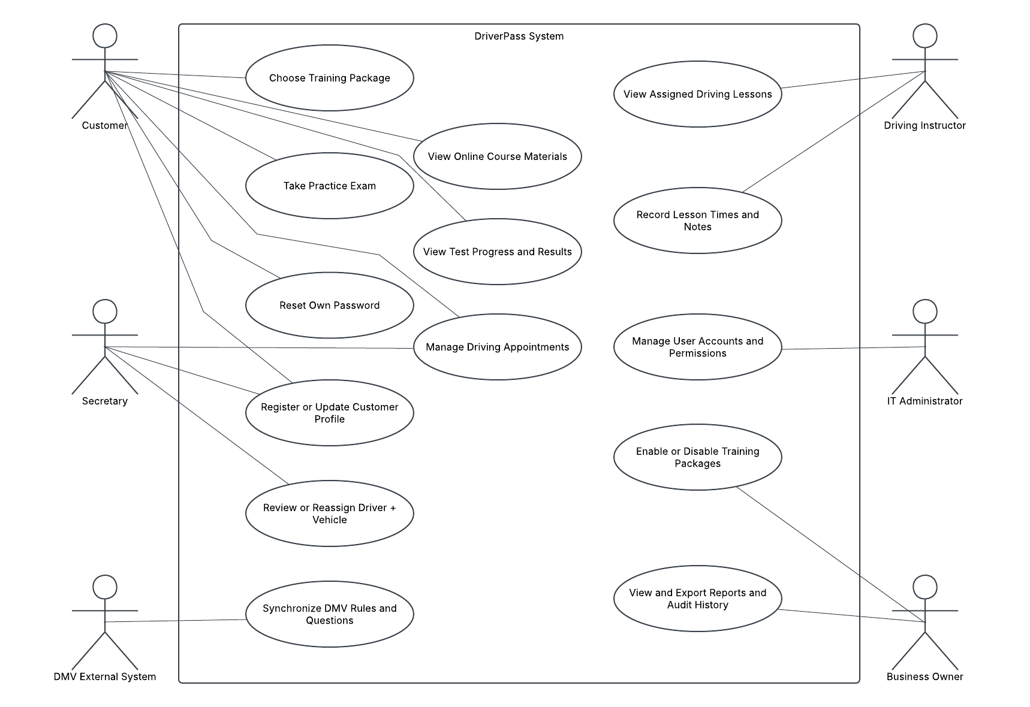

UML Activity Diagrams
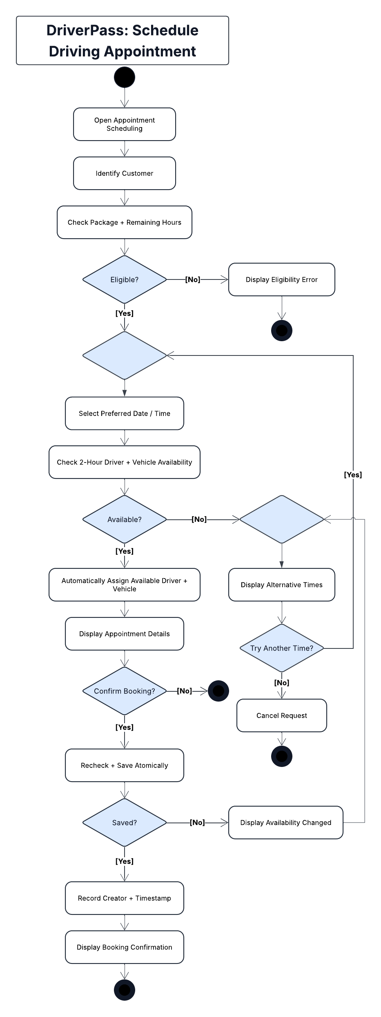  Driving Appointment Activity Diagram | 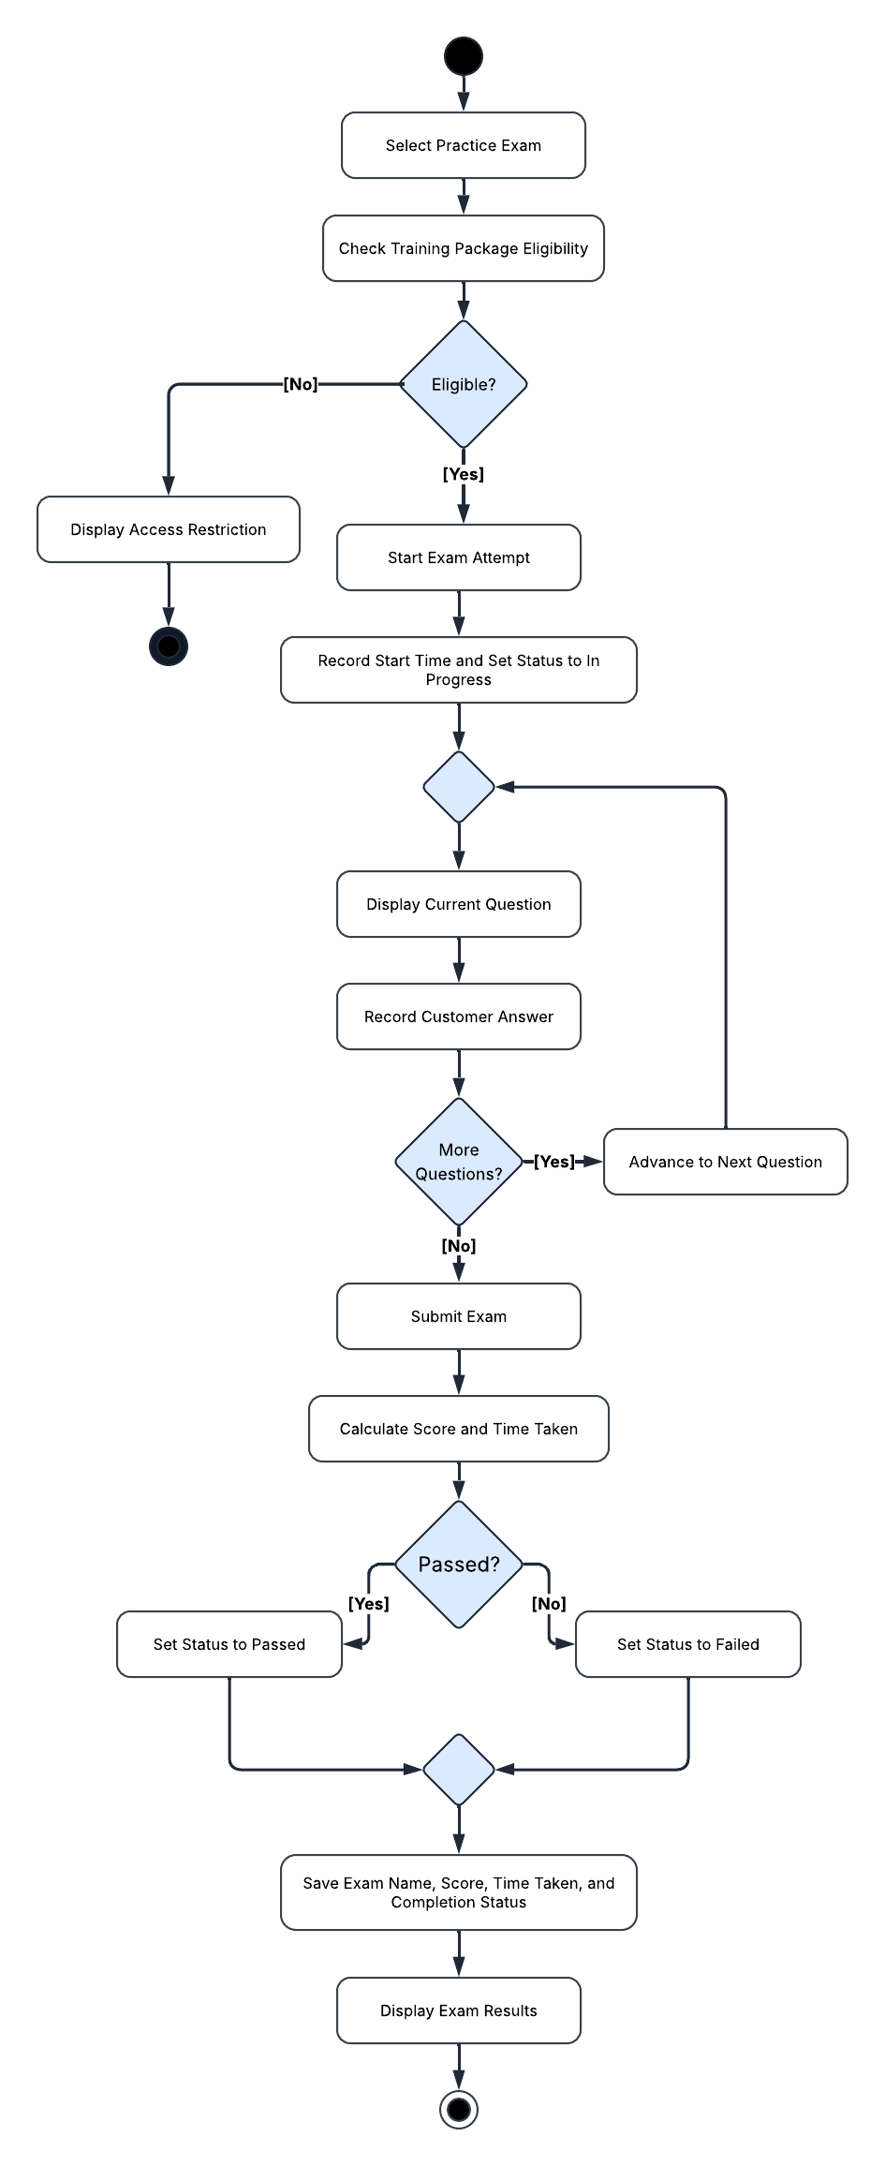  Practice Exam Activity Diagram

UML Sequence Diagram
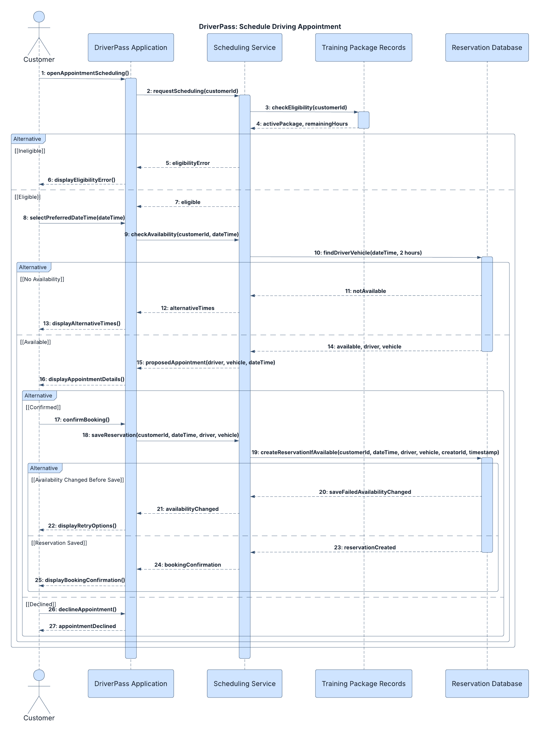

UML Class Diagram
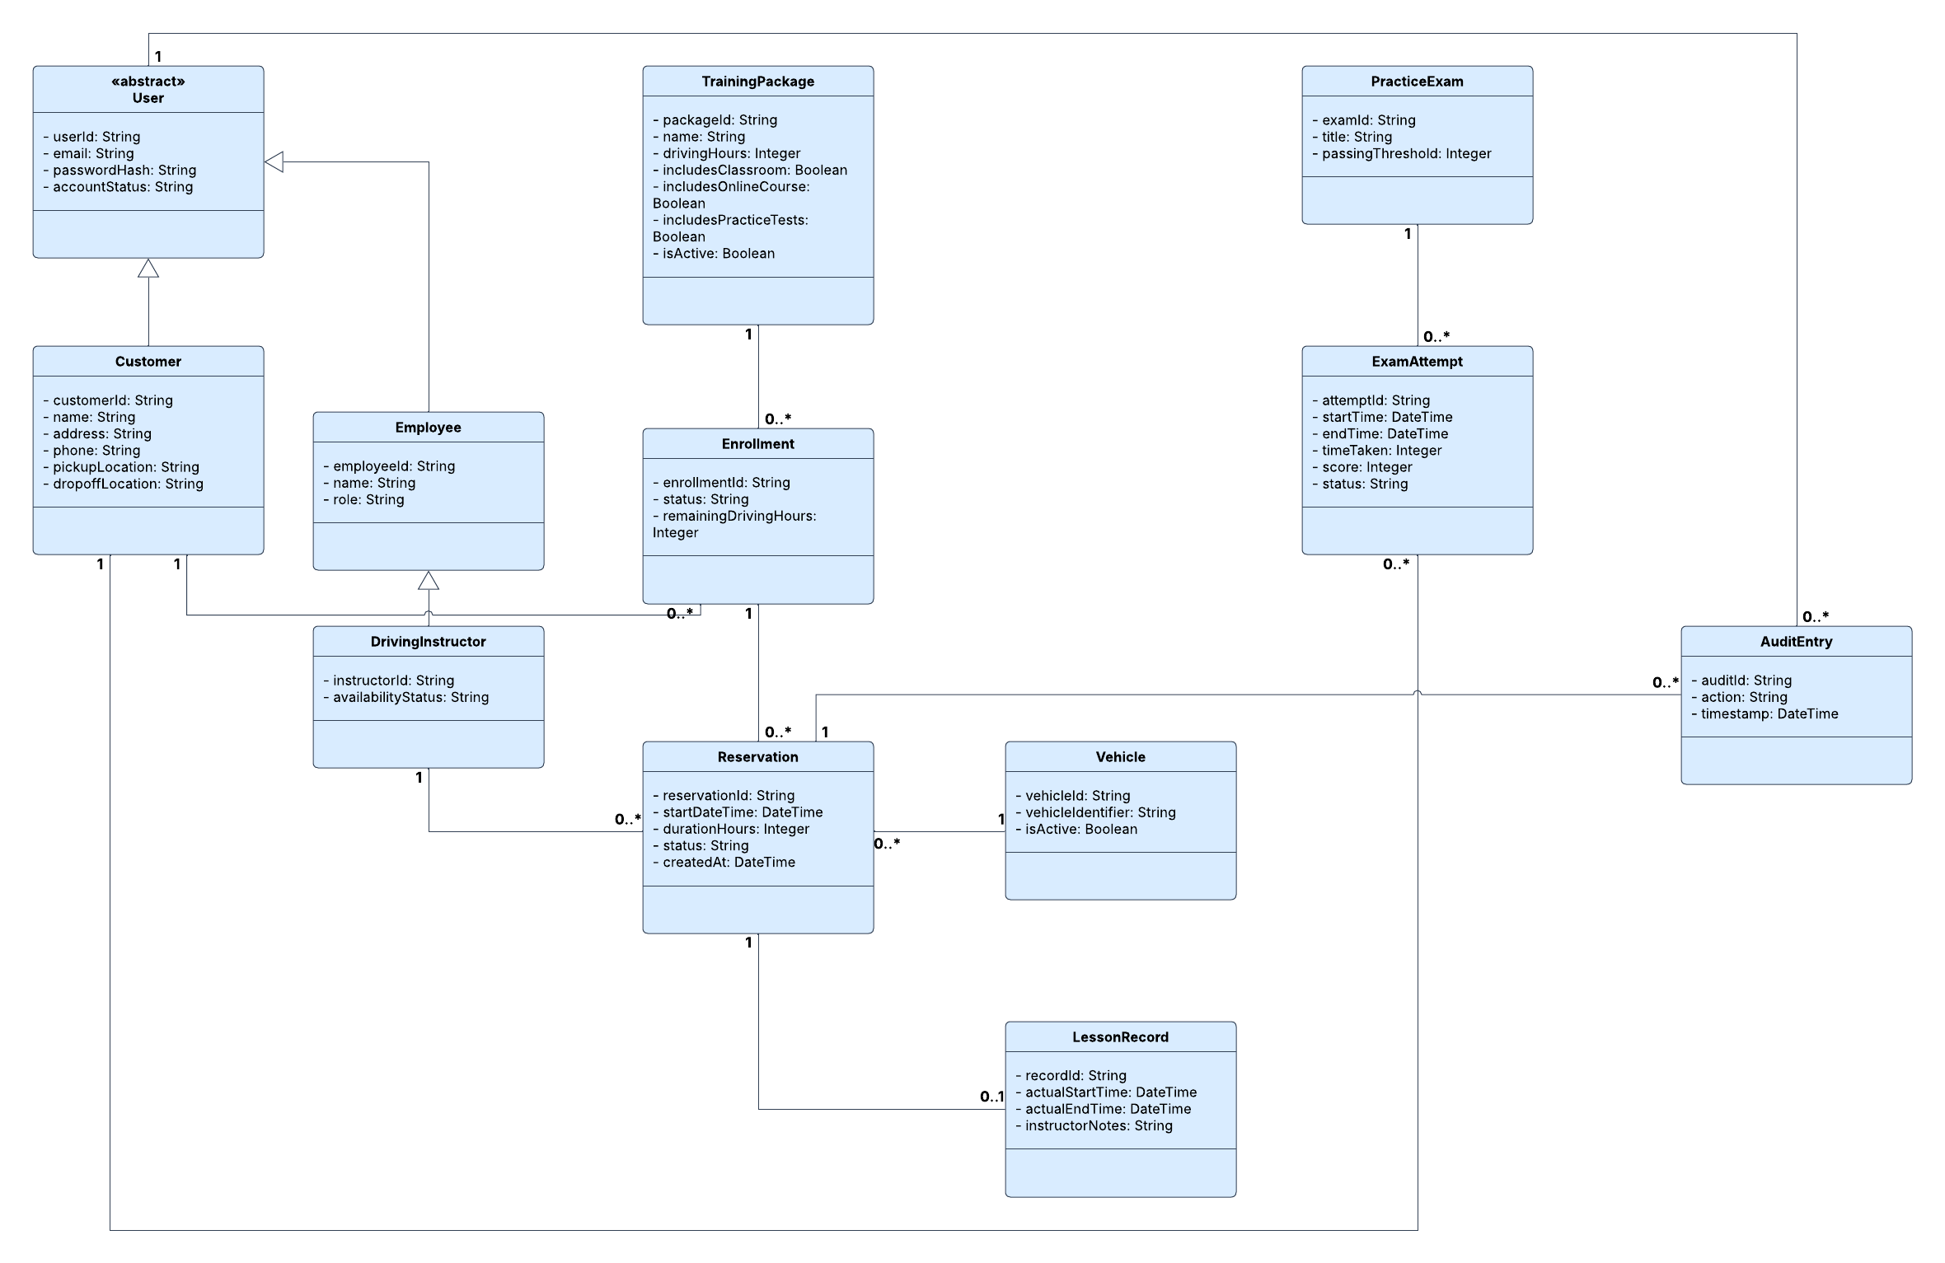

Technical Requirements

Hardware Requirements
- The DriverPass system will require cloud-hosted servers capable of running the web application, processing customer requests, and maintaining a centralized database. Cloud hosting will reduce the need for DriverPass to purchase and maintain its own server hardware.
- Customers and employees will need computers, tablets, or smartphones with compatible web browsers and reliable internet connections to access the system.
- The hosting environment will need sufficient processing power, memory, and storage to support customer accounts, training materials, practice exams, driving appointments, and business records.
- DriverPass employees will also need standard office equipment, including computers and printers, to manage customer information and produce reports.

Software Requirements
- The system will use a web-based application with a responsive interface that supports access from desktop and mobile browsers without requiring separate applications for each operating system.
- A centralized relational database will store information about users, customers, employees, training packages, enrollments, reservations, instructors, vehicles, lesson records, practice exams, exam attempts, and reservation activity history.
- The application will require scheduling functionality that verifies customers' available training hours, checks driver and vehicle availability, and automatically assigns available resources to two-hour appointments. Database transactions will help prevent conflicting reservations when multiple customers attempt to schedule appointments simultaneously.
- The system will provide access to online course materials and practice exams according to the customer's selected training package. Practice-test functionality will record exam scores, time taken, and completion status.
- Reporting functionality will allow authorized users to generate activity reports and export information in formats compatible with applications such as Microsoft Excel.
- The system will need an integration mechanism for receiving updated DMV rules, policies, and practice questions. The specific connection method will depend on what electronic resources the DMV makes available.

Security Requirements
- All users will access the system through authenticated accounts, with permissions determined by their assigned roles. Customers, instructors, secretaries, the business owner, and the IT administrator will have access only to the functions appropriate to their responsibilities.
- Connections between users and the web application will use HTTPS encryption to protect information transmitted over the internet. Sensitive information stored in the database will also require appropriate encryption and access restrictions.
- Account passwords will be stored using secure password hashing rather than plaintext. The system will support customer password resets and allow the IT administrator to disable accounts or modify permissions when necessary.
- The system will maintain an audit history of reservation changes, recording the responsible user, action performed, and timestamp.
- Because DriverPass collects customer payment information, payment details will require secure handling. A compliant payment service should be considered for sensitive card information, and card security codes must not be retained after authorization.

Infrastructure and Development Tools
- The proposed infrastructure will use a cloud-hosting provider to manage application servers, database services, network connectivity, and backup storage. The environment should support system monitoring, regular backups, and recovery procedures to minimize service interruptions and data loss.
- The system will maintain one centralized source of current information. Users must be connected to the internet to create or modify records, although authorized users may download reports and other information for offline review.
- The development team will need tools for application development, database administration, software testing, and version control. Git and GitHub can support source-code management, while Lucidchart provides the UML models used to guide implementation.
- Testing tools will be needed to verify account permissions, scheduling availability, reservation conflict prevention, exam scoring, and the accuracy of stored records before deployment.
- The infrastructure should support ongoing maintenance and updates, including changes to training materials, DMV requirements, and training packages. The business owner will be able to disable existing packages, while more substantial changes to package functionality may require developer assistance.

